Name : Khizar Dar

OS LAB 12

Task 1:

Bankers Algorithm:

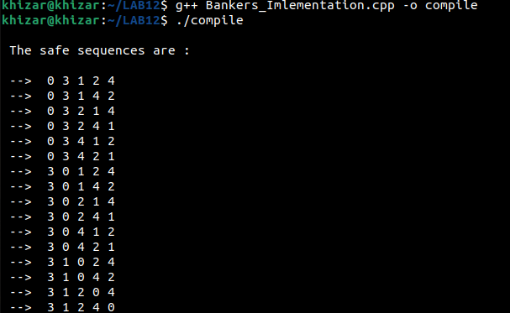

Task 2:



Task 3:

